* **Stock Take**

1. **Click Menu**
2. **Click Reports**
3. **Click Stock Take**

Menu

Stock Take

Reports

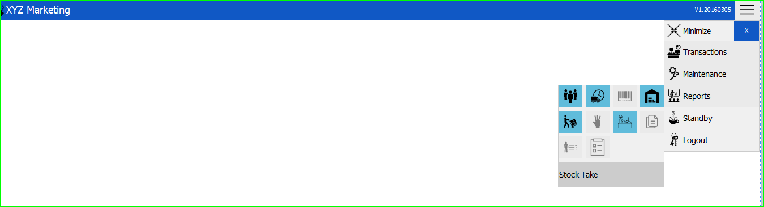

* **New Stock Take Transaction**

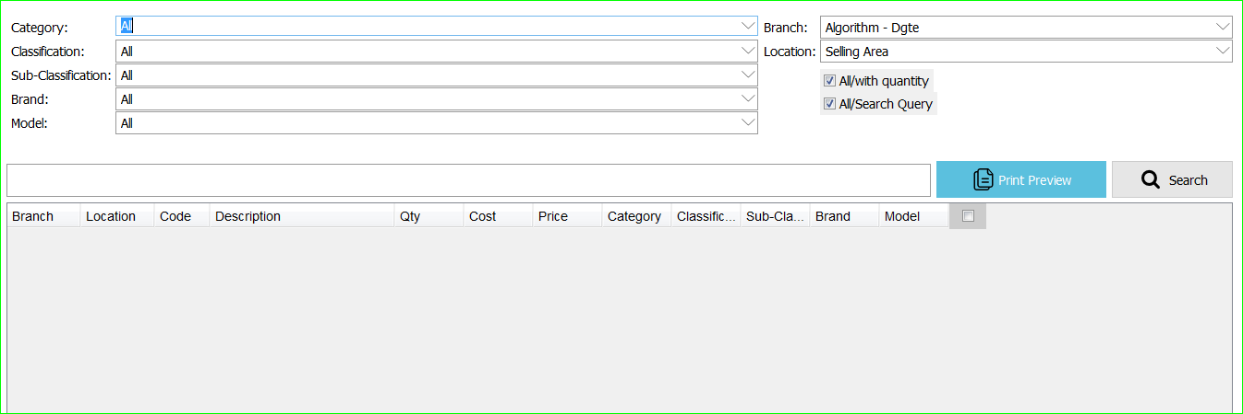

Search Tab

Location

Branch

Search

Model

Brand

Sub-Classification

Classification

Category

Search Options

Print Preview

1. Choose Category
2. Choose Classification

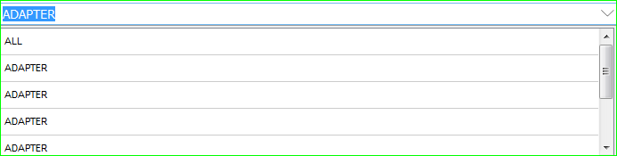

1. Choose Sub-Classification

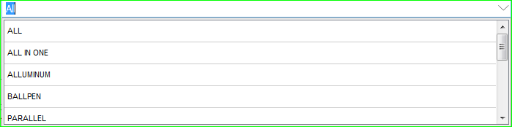

1. Choose Brand

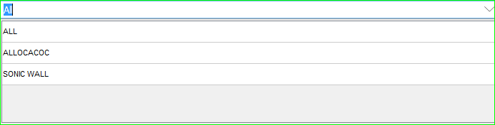

1. Choose Model

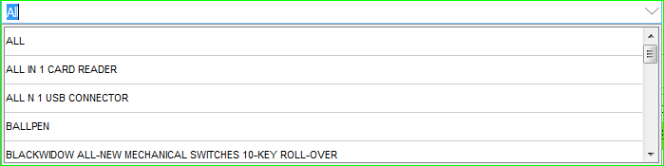

1. Search Tab



**Input the item you want to search.**

1. 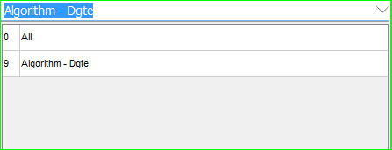Choose Branch
2. 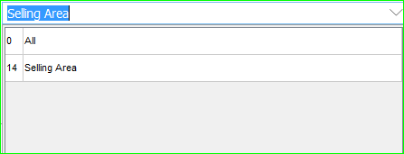Choose Location
3. Choose Search Options
   1. All/With Quantity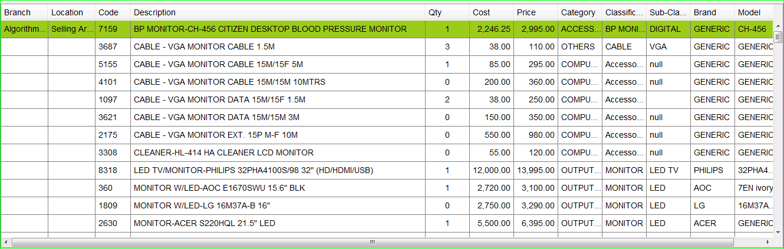

**Note: It will show including the 0 quantities.**

* 1. 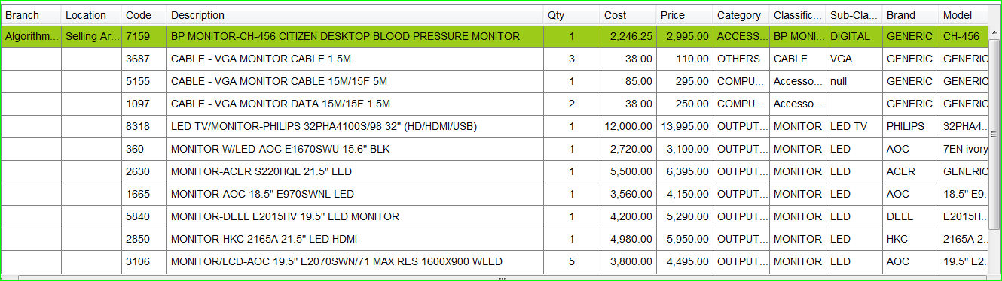 All/Search Query

**Note: It will not display with 0 quantities.**

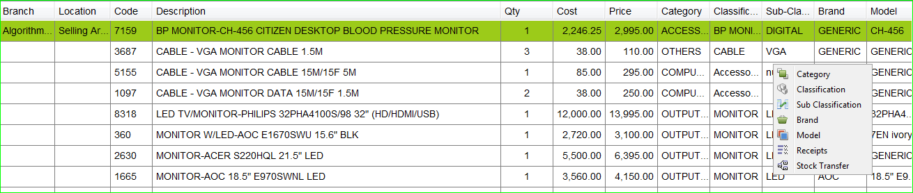**For a null sub-category, you can just click it to change its category, classification, sub-classification, brand, model, receipts or its stock transfer.**

1. 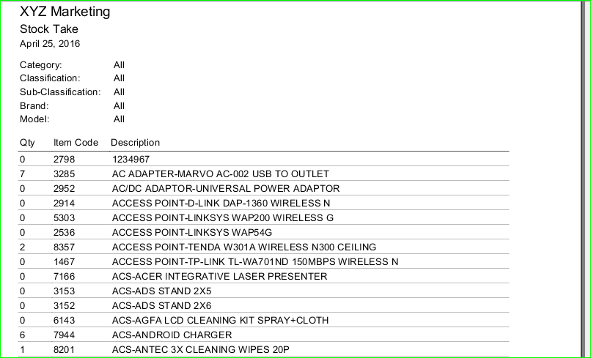Print Preview
2. Search

**After you enter the item on the search bar, click the search button to see results.**